Instructions for getting and using Excel add-ins

Clay Swackhamer 2018

swackhamerclay@gmail.com

# **1. Download:**

1. Go to to download the files
2. Download the folder called “doge” (should be a zipped folder after downloading)
3. Extract all files

# **2. Install:**

1. Go to folder “for redistribution” and double click the file MyAppInstaller_web.exe
2. Follow the prompts to install the function as well as MATLAB runtime
3. Open Microsoft Excel
4. Go to “File”--> “Options”--> “add ins”-->Manage Excel add in--> “Go”-->”Browse”-->navigate to the folder “for_redistribution_files_only” and select “doge.xla”

# **3. Use the formula:**

1. Open Microsoft Excel
2. In an empty cell, type “=doge()” (the doge function has no argument)
3. This brings up a doge. Give it a minute, the first time the function calls it takes a while. The next time you call it the function should execute faster.

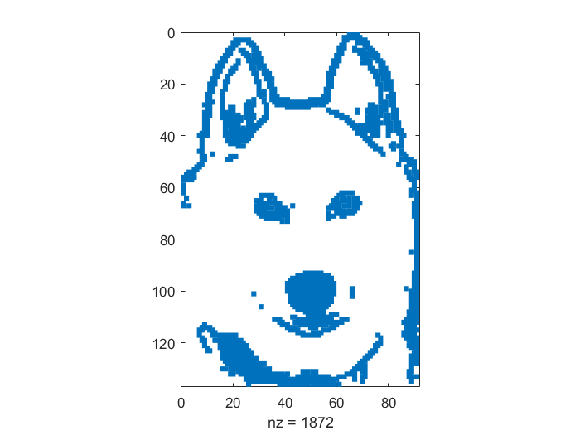

**4. Repeat**

1. Repeat steps 1 through 3 for other functions that you want to use. Note: You only need to download Matlab runtime once. The you can use any of the functions.